**CDA RFP**

**1.0 Problem Description**

To create a compelling and impressive VR video game experience.

**2.0 Objectives**

The experience of playing the game should show off the skills of UI students and staff.

Players should be impressed with the functionality, graphics, professionalism, and gameplay.

**3.0 Current Systems**

Dr. BC’s computer (specifications are unknown, but adequate to run similar games)

Vive VR system with 2 handheld controllers.

Unity 2018.2.7 (on Windows)

Visual Studio and libraries. (3D) or Code Blocks

**4.0 Intended Users**

BC, people who come to see our game, STEAM users?

**5.0 Known Interactions**

Motion sickness and disorientation can be a serious problem in VR games for some users.

**6.0 Known Restraints To Development**

The Vive, VR, and current development tools are still actively being developed and refined. This can lead to several things. Delays, learning curves, unknown and unforeseen interactions, and a lack of user base documentation for programmers to fall back on.

In addition, the current development team is not experienced with creating 3D games. This will

**7.0 Product Schedule** 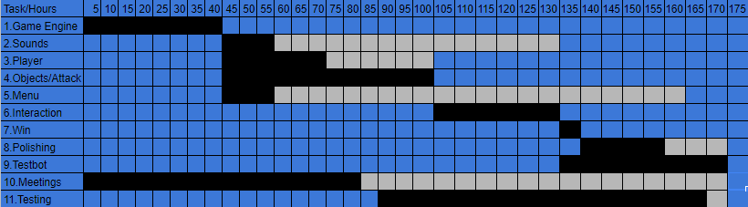

Basic Pong framework and then adding gameplay features

**8.0 Glossary**

**VR** – Virtual Reality

https://en.wikipedia.org/wiki/Virtual_reality

**Vive** – Game system platform

https://en.wikipedia.org/wiki/HTC_Vive

**Visual** **Studio** – coding environment for C#

https://en.wikipedia.org/wiki/Microsoft_Visual_Studio

**Code** **Blocks** – coding environment for C#

http://wiki.codeblocks.org/index.php/Help:Editing Unity – 3D game development platform

**Unity** – coding environment focusing on 3D objects and game engines

https://en.wikipedia.org/wiki/Unity_(game_engine)

C# - Language based on C++ and developed by Microsoft. Used in Unity.

https://en.wikipedia.org/wiki/C_Sharp_(programming_language)

9.0? Game specifications

Projectile balls come at the player in 3D

Various power ups (user requested) such as larger paddles, invulnerability, and shields.

The game should have background music and sound effects, but unlike Audioshield, this game will not be paced to the background music.

Possibly have bricks

To increase difficulty:

More projectiles

Projectiles move at a faster rate

Angle that projectiles come from increases